**Safer Tek Backend Exam**

**Name: - Suraj Kumar Tellakula**

**ID NO: -2100032404**

**Q)** For this example, let's assume we have a simple database for a retail store. Our database has the following tables:

1. Customers : Information about customers.

2. Products: Information about products.

3. Orders: Information about orders made by customers.

4. OrderItems: Information about items in each order.

Table Structures

Customers

CustomerID FirstName LastName Email DateOfBirth

1 John Doe john.doe@example.com 1985-01-15

2 Jane Smith jane.smith@example.com 1990-06-20

Products

ProductID ProductName Price

1 Laptop 1000

2 Smartphone 600

3 Headphones 100

Orders

OrderID CustomerID OrderDate

1 1 2023-01-10

2 2 2023-01-12

OrderItems

OrderItemID OrderID ProductID Quantity

1 1 1 1

2 1 3 2

3 2 2 1

4 2 3 1

Sample Queries

1. List all customers.

2. Find all orders placed in January 2023.

3. Get the details of each order, including the customer name and email.

4. List the products purchased in a specific order (e.g., OrderID = 1).

5. Calculate the total amount spent by each customer.

6. Find the most popular product (the one that has been ordered the most).

7. Get the total number of orders and the total sales amount for each month in 2023.

8.Find customers who have spent more than $1000.

**Sol: - 1) Solution in SQL :**

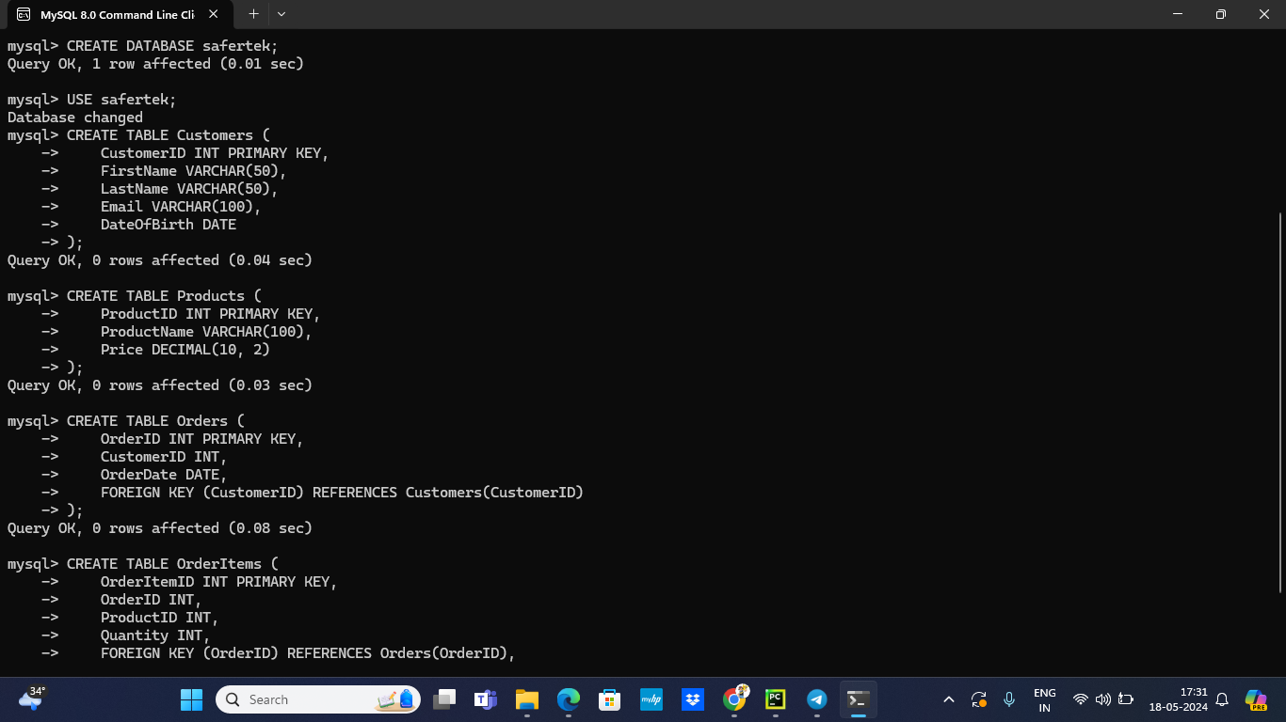

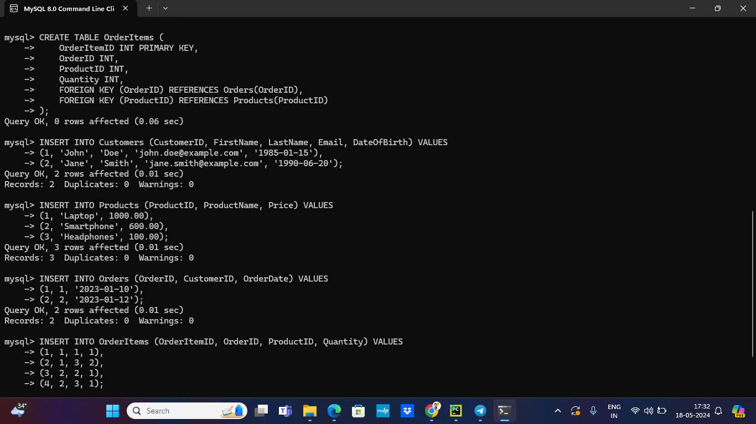

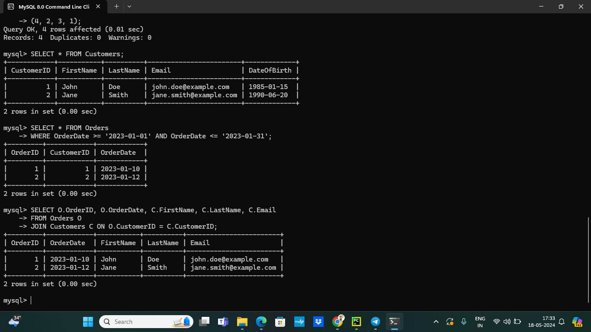

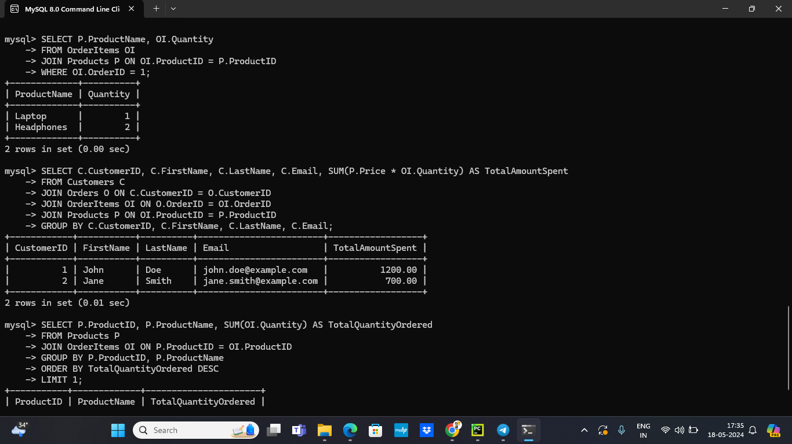

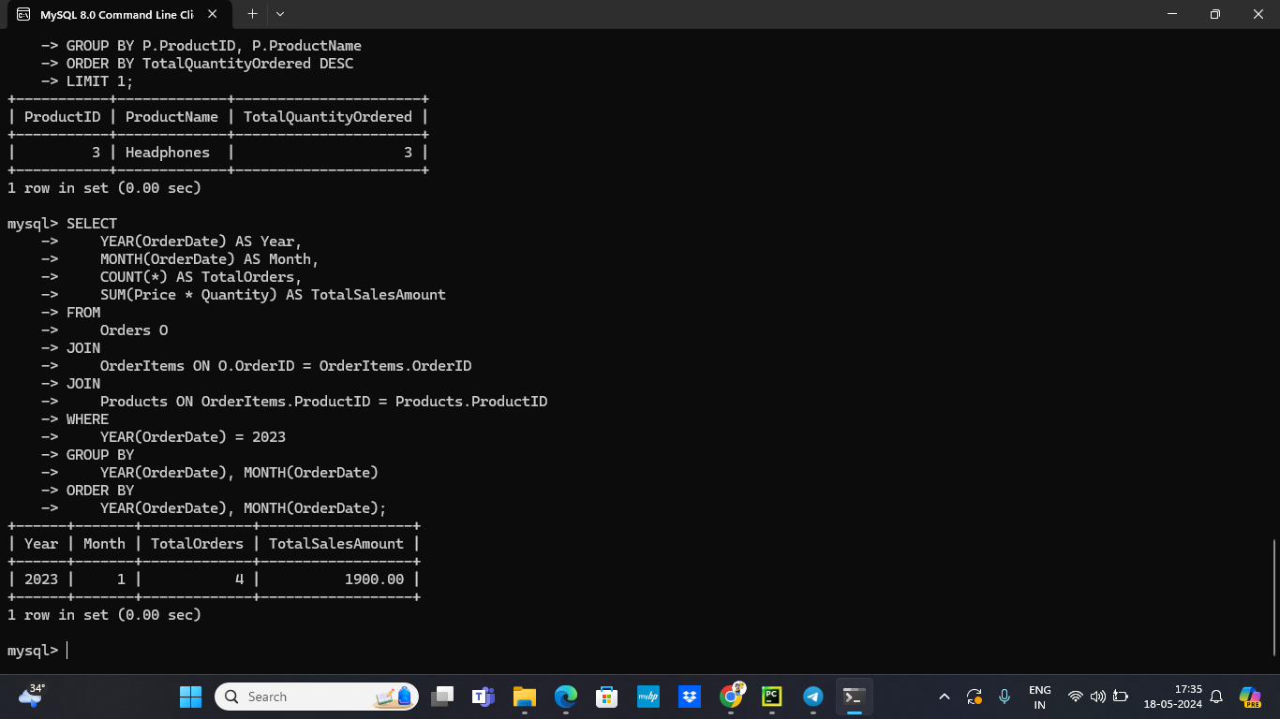

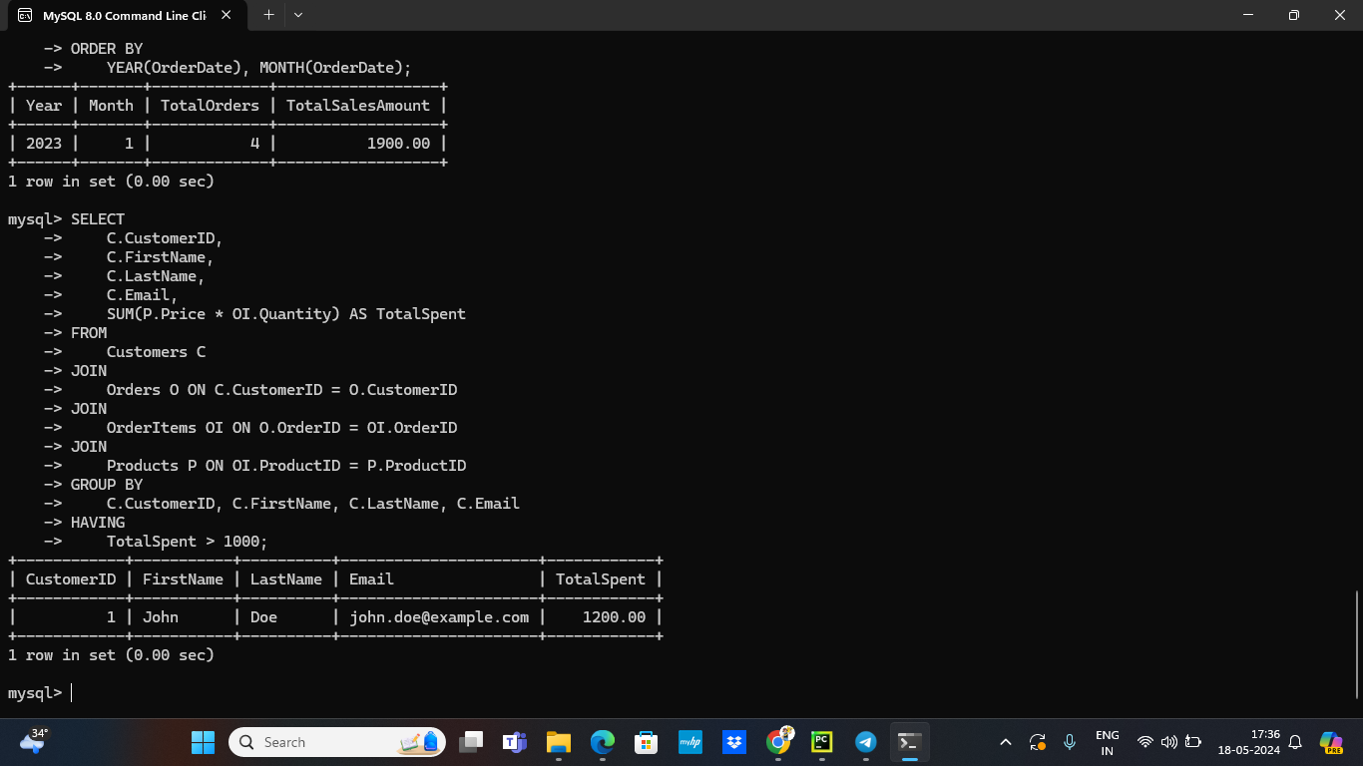

**2) Solution in Python :**

